

# Wireless World

**Supervisor:** *NGUYỄN HẠ VY*

**Semester:** *01*

**Batch No:** *T1.2302.M0*

**Group No:** *03*

|  |  |  |
| --- | --- | --- |
| **Order:** | **Full name** | **Roll No.** |
| *1.* | *ĐẶNG ĐẠI DƯƠNG* | Student1455772 |
| *2.* | *HUỲNH TUẤN DUY* | Student1455048 |
| *3.* | *PHẠM ANH VŨ* | Student1455055 |
| *4.* | *PHẠM ĐẮC AN* | Student1455062 |

***Month****: 6* ***Year****: 2023*

**Table of contents**

1. Acknowledgements

2. eProject Synopsis

3. eProject Analysis

4. eProject Design

5. Pages and Features

6. Source Code with Comments

7. User Guide

8. Developer’s Guide

9. Conclusion

10. References

**Acknowledgements**

In the process of implementing this project, we would like to express our sincere gratitude and appreciation to the individuals and organizations who have supported and facilitated the smooth completion of this project.

First and foremost, we would like to thank our project supervisor, Ms. Nguyen Ha Vy, for imparting her expertise and providing guidance throughout the project. Her valuable instructions and directions have helped us overcome obstacles and stay on track. We appreciate her dedication and commitment to enlightening and guiding us towards the progressive civilization of human society knowledge.

Next, I would like to extend my gratitude to the team members of the project. Despite the challenges in communication among team members at the beginning, we managed to find ways to overcome them and create an efficient and positive working environment for the majority of the project timeline. I appreciate the collaborative support, efforts to meet deadlines, and valuable contributions from each of you, which have played a significant role in the success of this project.

I would also like to express my thanks to our families and friends. It is through their encouragement and understanding that we have found the motivation to overcome challenges and difficulties during the project implementation. Thank you for always believing in and supporting us.

Furthermore, I would like to express my gratitude to the authors collaborating with APTECH India who have shared their materials and knowledge on C programming language, HTML, CSS, JavaScript, AngularJS. These resources have provided essential information to establish a solid foundation before participating in the eProject. Another invaluable resource that cannot be overlooked is the YouTube videos. Thanks to these videos, our team has gained a deeper understanding of the learned concepts and their practical applications. We are grateful to the YouTube creators for their efforts in sharing valuable knowledge with the community.

Finally, I would like to thank all those who have supported and contributed to the success of this project.

**eProject Synopsis**

***a. Brief Overview of eProject***

The eProject was created to address the difficulties and challenges that IT students face in applying the knowledge they learn in the classroom to real-life situations. Participating in eProject is a way for students to experience and become familiar with the real-world work environment right in the classroom by following a laddered approach.

The main objective of eProject is to provide students with practical experience in building large and robust applications that can be applied in real life. By breaking down a large project into smaller, more manageable issues and concepts, it is easier to manage and enables students to gradually build their understanding and skills, starting from simple concepts to more complex ones, and then applying them in stages. This helps students to improve their skills and build a strong foundation of practical knowledge and experience, enabling them to achieve their learning goals sooner.

The scope of eProject includes many aspects of application development, where students can work on real-world projects and face the complexity and demands of the IT industry. eProject meets the real needs of a learning environment that can keep up with the fast pace of technology. It provides students with a flexible solution and removes barriers of geography and busy schedules of students to improve learning effectiveness and implement concepts at their own pace.

Overall, eProject revolutionizes the way of learning, equipping students with the tools to meet the demands of the IT industry, stimulating a desire for learning, and enhancing practical skills and applicability to achieve success in the field.

***b. Objective of this eProject***

The objective of this eProject is to develop a Single-Page-Application and responsive website for Wireless World, an international consumer electronics company. The website aims to provide an attractive and user-friendly platform for customers to explore and purchase electronic products.

The website will be built for the Windows platform using HTML5, JSON, Angular JS, JavaScript, and Geolocation. It should be compatible with leading browsers such as Chrome, IE, and Firefox.

**Key Requirements:**

1. Design and Layout: The website will be designed as a visually appealing Single-Page-Application with proper sections, graphics, and a company logo. It should incorporate attractive fonts, colors, and animations to enhance the user experience. The layout should be responsive, adapting to different screen sizes.
2. Menu and Categorization: A comprehensive menu will categorize the available information about the features provided on the site. This includes menus for various cell phone brands, features of cell phones, and more. The information should be organized based on brand names, allowing users to explore specific brands or view all available mobile phones.
3. Featured Sections: The website should include sections showcasing the top-selling mobile phones, best budget smartphones (under $200), and best offers on mobile phones. Each section should display relevant information and accompanying images.
4. Individual Phone Details: The website should provide detailed information about individual cell phone models, including their features and images. This will allow users to make informed decisions when selecting a phone.
5. Phone Comparison: Users should have the ability to select and compare up to three mobile devices. A dedicated comparison section will present a tabular format comparing the features of different phone models within the same brand or across different brands.
6. Visual Appeal: The website's color schemes should be soothing, with the option of using pastel colors. Additionally, when displaying specific brand phones, the background image should feature the logo of the corresponding brand.
7. Additional Pages: The website should include essential pages such as About Us, Site Map, Gallery, and Contact Us. These pages will provide additional information and enhance user engagement.
8. User Registration: The website will support two types of users: registered and non-registered. Registered users will have the ability to add products to their cart, while non-registered users can browse the products without the option to purchase.

**Functionalities to Implement:**

In addition to the requirements mentioned above, the website should incorporate the following functionalities:

* Continuous Scrolling Ticker: Display a ticker at the bottom of the page, continuously updating with the current date, time, and location using the geolocation features of HTML5.
* Visitor Count: Show a visitor count at the top right corner of the page, next to a logo image, indicating the number of visitors to the website.
* Interactive Menu: Change the color of menu options on hover and after clicking to provide visual feedback to users.
* Fade-In/Fade-Out Effects: Utilize fade-in and fade-out effects for menus, enhancing the visual appeal and transitions on the website.

By implementing these features and functionalities, the eProject aims to create a user-friendly and visually appealing Single-Page-Application and responsive website for Wireless World, enabling customers to explore and purchase electronic products conveniently.

**eProject Analysis**

**3.1 User Requirement**

In today's era, browsing the web on mobile phones has become more prevalent than ever before. This creates a growing demand for speed and user-friendly experiences on websites

Users expect mobile phone e-commerce websites to provide smooth and fast interactions, with an interface that is easy to use and compatible across mobile devices. They aim to efficiently find relevant information while minimizing the encounter with irrelevant information or complex transaction processes.

Another important aspect that users care about is the registration process. They desire a simple, uncomplicated registration process that doesn't involve too many steps. Users want to be able to create an account quickly and easily to continue exploring and utilizing the website's features.

Information security is also a critical concern for users. They want assurance that their personal information and transactions are securely protected. Mobile phone e-commerce websites need to implement effective security measures, including password encryption and authentication mechanisms, to ensure user information is safe and secure.

**3.2 Functional Requirements**

* Search and Filtering: The website should provide users with the ability to search for specific products based on keywords, categories, brands.
* Product Display: The website should present detailed information about each product, including product images, descriptions, specifications, and pricing. The display should be visually appealing and user-friendly, allowing customers to easily view and compare different products.
* Shopping Cart Functionality: Users should be able to add products to a shopping cart, view the contents of their cart, and modify quantities or remove items as needed. The shopping cart should provide a seamless and intuitive experience, enabling users to proceed to the checkout process smoothly.
* Payment Methods: The website should support various payment methods, such as credit cards, debit cards, digital wallets, and other secure online payment options. The integration with a trusted payment gateway or service is essential to ensure secure and reliable transactions.
* Wishlist: The website can incorporate a wishlist feature that allows users to save products they are interested in for future reference or purchase. This feature enhances user engagement and facilitates easy access to desired products.

**3.3** **Responsive Design**

Responsive design is essential for the success of an e-commerce website. With the expansion of various devices such as smartphones, tablets and desktop computers, customers access websites from different screen sizes and resolutions. It is crucial to ensure that the website is optimized and adapts seamlessly to these devices, providing a consistent and user-friendly experience.

A significant advantage of a responsive website is that its layouts and elements will automatically respond and reposition themselves appropriately based on the screen size of the user. This ensures that users can easily navigate and interact with the website regardless of the device they are using. By adopting responsive design techniques, the website can offer a consistent user interface, enhancing usability and reducing the need for zooming or horizontal scrolling.

From a business perspective, responsive design is crucial for maximizing conversions and sales. When the website is optimized for different devices, users are more likely to stay longer, explore products, and make purchases. With the increasing trend of mobile shopping, a responsive design ensures that potential customers can access the website on their smartphones and tablets, resulting in increased traffic and potential revenue.

**3.4 Single-Page-Application (SPA)**

The Single-Page-Application (SPA) approach offers numerous benefits and considerations for an e-commerce website, enhancing the user experience by providing smooth and fast interactions without the need for full page reloads, lead to increasing user engagement and satisfaction.

Unlike traditional multi-page websites, where each click results in a full page reload, an SPA loads the initial HTML, CSS, and JavaScript resources only once. Subsequent interactions, such as browsing different product categories, adding items to the cart, or applying filters, are handled dynamically by making asynchronous requests to the server for data updates. This eliminates the need for reloading the entire page, resulting in faster response times and a smoother user experience.

However, it is important to consider some considerations when adopting an SPA architecture. Since proper handling of browser history, deep linking, and SEO optimization can be challenging in SPAs.

**3.5 Constraints and Limitations**

The design and implementation of a selling phone e-commerce website may be subject to various constraints and limitations that could impact the project.

One of the constraints is that the team members lack a designer background. This limitation may affect the visual aesthetics and user experience of the website. Without professional design skills, creating visually appealing layouts, choosing appropriate color schemes, and ensuring a cohesive overall design may present challenges. However, The team can mitigate these issues by searching for and learning these new skills online, mostly on Youtube.

Another constraint is the limited timeframe of one month for the project. Developing a complete selling phone e-commerce website within such a short time frame can be demanding. It may require the team to prioritize essential features and functionalities, streamline the development process, and adequate planning, task prioritization.

With no financial resources allocated for the project, the team may face limitations in acquiring premium tools, plugins, or external services that could enhance the website's functionality or improve development efficiency. To deal with this we explore open-source and leverage free resources.

The team members having only a basic understanding of languages like C, HTML, CSS, and Angular may present a challenge. Limited experience with these technologies may slow down the development process and result in code quality issues. It is crucial to allocate time for learning, conducting research, and seeking guidance from online resources and mentors. These can help mitigate this limitation.

**eProject Design**

**a. Wireframe**

The design phase of the eProject involves creating the visual layout and structure of the website/application.

***Homepage layout (desktop)***

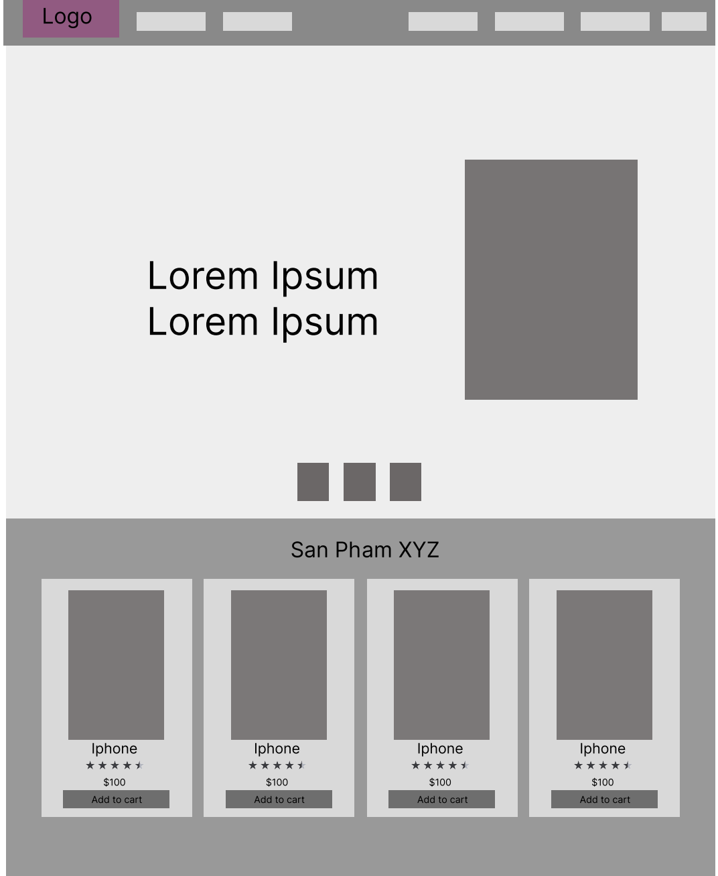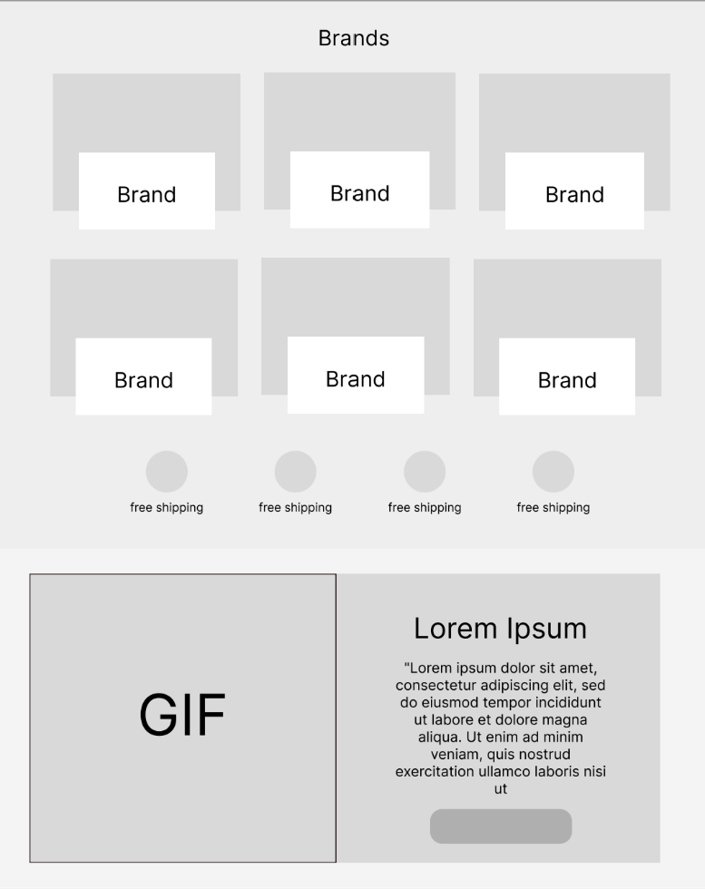

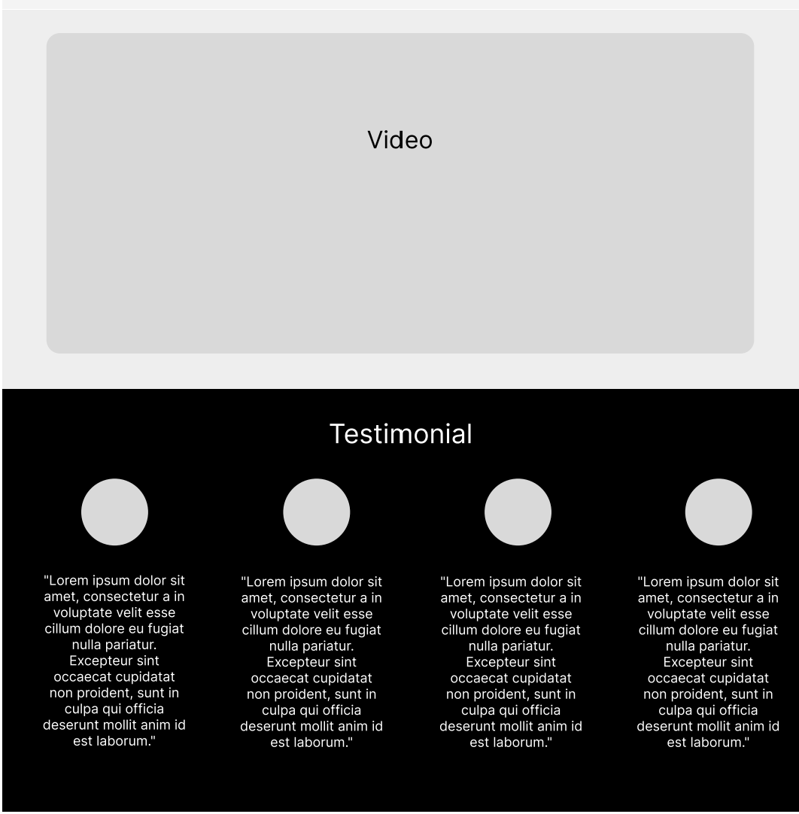

***General Product Layout (desktop)***

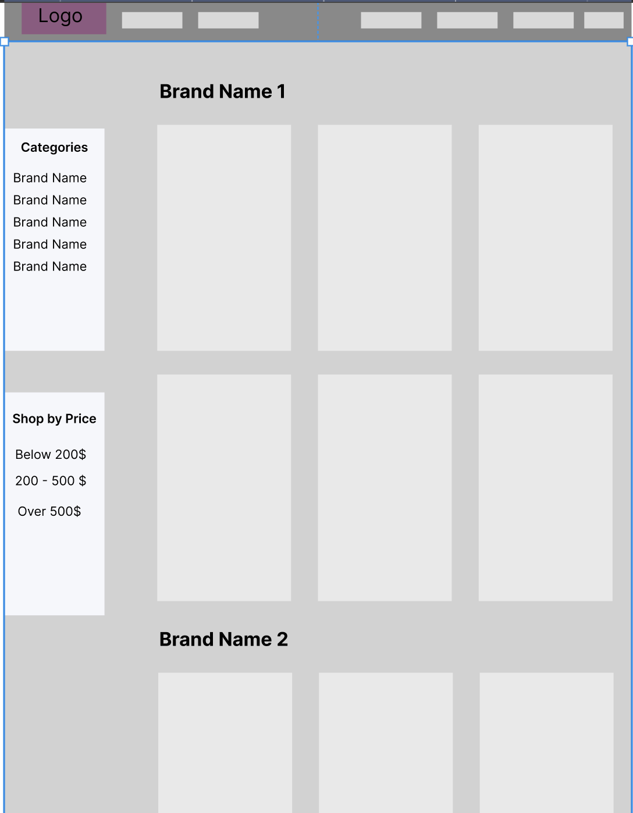

***Specific Product Layout (desktop)***

***Comparation Layout (desktop)***

**b. Flowcharts**

The Flowcharts section showcases visual representations that illustrate the logic and flow of various processes and functionalities within the website. These flowcharts serve as a valuable tool to map out the user experience and provide a comprehensive understanding of how the website functions. By visually depicting the processes and decision points, the flowcharts offer insights into the overall structure and operation of the project.

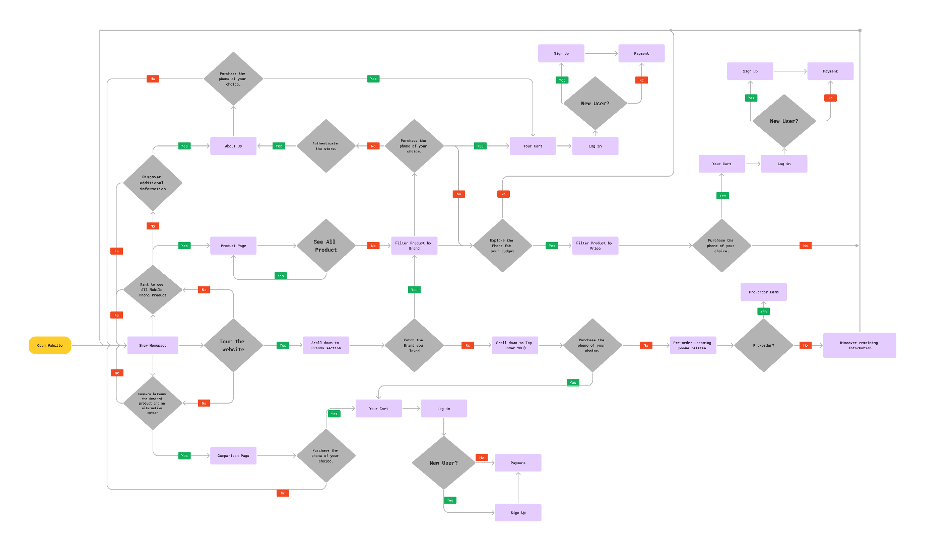

Figure 1. Whole Flowchart of the website

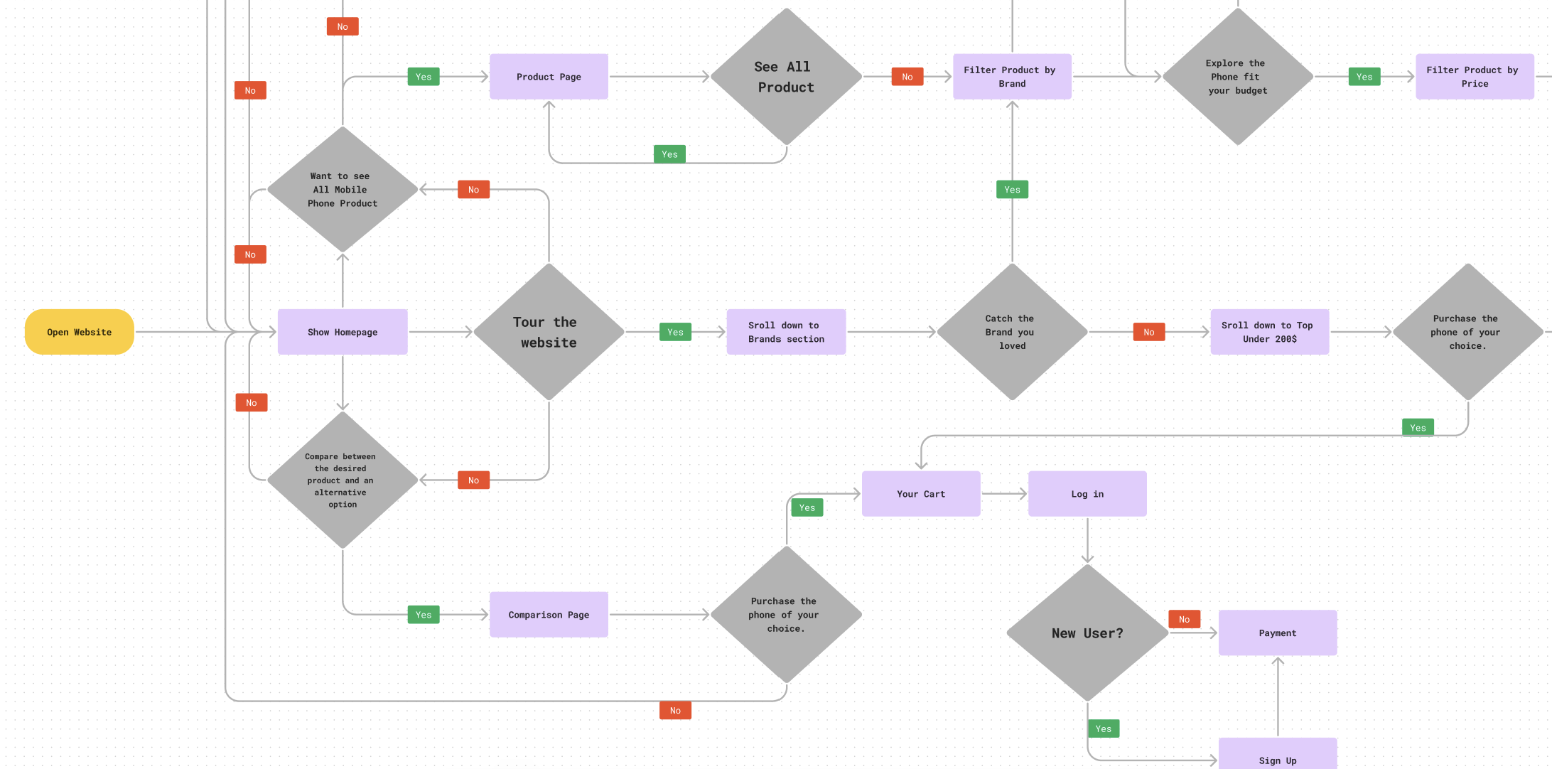

Figure 2: Main part from the Flowchart